Rebecca Ferjo
CS-540
Project One: Part Two Data-Driven Narrative
Purpose and Audiences
The purpose of this data-driven narrative is to examine California unemployment patterns from 2000 through 2025 and show how county population provides additional context for current labor-market conditions. The analysis combines population estimates from the California Department of Public Health (CDPH) with Local Area Unemployment Statistics from the California Employment Development Department (EDD). Combining the datasets makes it possible to move from a statewide historical view to a county-level comparison rather than interpreting unemployment or population independently (CDPH, 2026; EDD, n.d.).
The first stakeholder group is California state workforce and economic-development leaders. These decision-makers need a broad view of labor-market changes to support funding, workforce programs, and resource allocation. The second group is county and local workforce-development officials, whose decisions are more closely tied to individual communities. Local officials need to know which counties are experiencing high unemployment and how the size of those communities provides context for the rates. These audiences therefore benefit from different levels of detail while using the same integrated data.
Data-Driven Narrative
The statewide trend shows a labor market that has experienced both long periods of improvement and sharp disruptions. California’s unemployment rate was approximately 5% in 2000, increased in the early 2000s, and then declined during the middle of the decade. Beginning around 2008, unemployment rose sharply and reached more than 12% around 2010. The rate then declined through much of the 2010s, eventually reaching approximately 4% before another sudden increase to about 10% in 2020. After that spike, unemployment fell substantially, although the visualization shows an upward movement again in the most recent years, reaching approximately 5.5% in 2025.
This historical view gives state leaders important context. The recent increase is much smaller than the largest peaks in the series, but the change in direction is still worth monitoring. It also demonstrates why a single year should not be interpreted without considering the larger pattern. The LAUS dataset is appropriate for this comparison because it provides labor-force, employment, unemployment, and unemployment-rate estimates at state and local levels (EDD, n.d.).
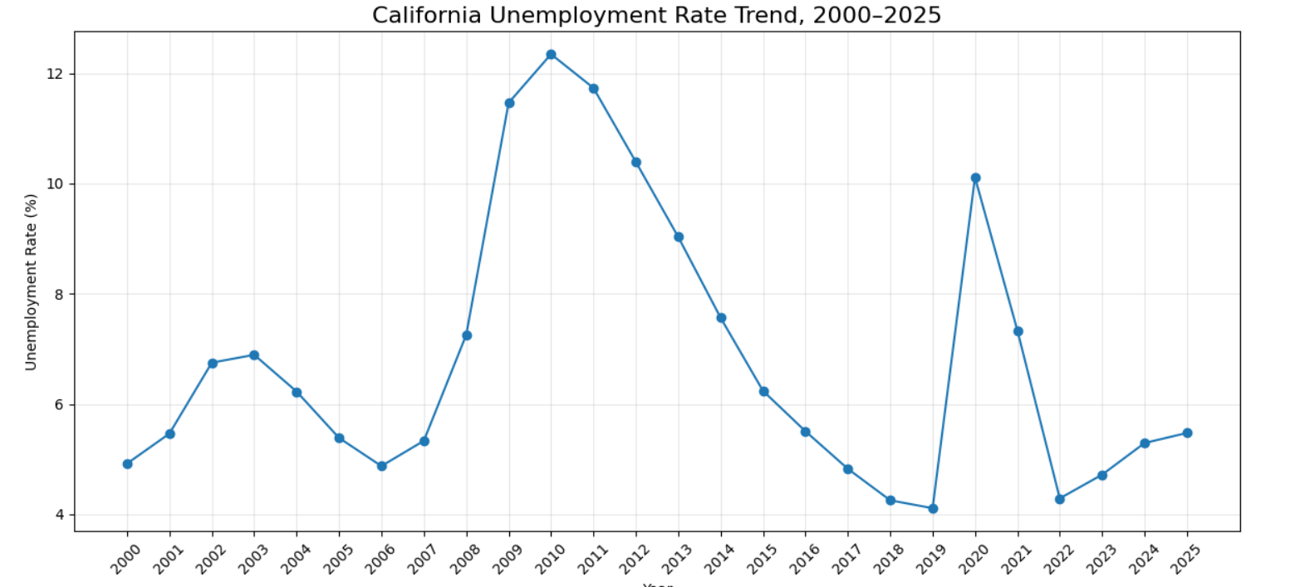
Figure 1. California unemployment rate trend, 2000–2025. Created from California EDD LAUS data.
The county-level view reveals a second part of the story. In 2025, Imperial County had the highest unemployment rate in the analysis at approximately 18.8%, followed by Colusa County at 13.9% and Tulare County at 10.8%. Merced, Kings, Kern, Sutter, Fresno, Madera, and Monterey Counties also appeared among the ten highest-rate counties. These results show why the statewide rate alone is not enough: a statewide unemployment rate near 5.5% can conceal communities experiencing considerably higher unemployment.
Population adds useful context to those differences. Imperial County’s high unemployment rate occurred in a community with a population of approximately 186,620, while Fresno County had a lower unemployment rate of approximately 8.5% but a population exceeding one million. Kern County similarly combined an unemployment rate of approximately 9.0% with a population above 924,000. Population should not be treated as the number of people in the labor force or the number unemployed; instead, it helps describe the scale of the community experiencing the labor-market conditions. The CDPH dataset provides county and local-health-jurisdiction population estimates that make this added context possible (CDPH, 2026).
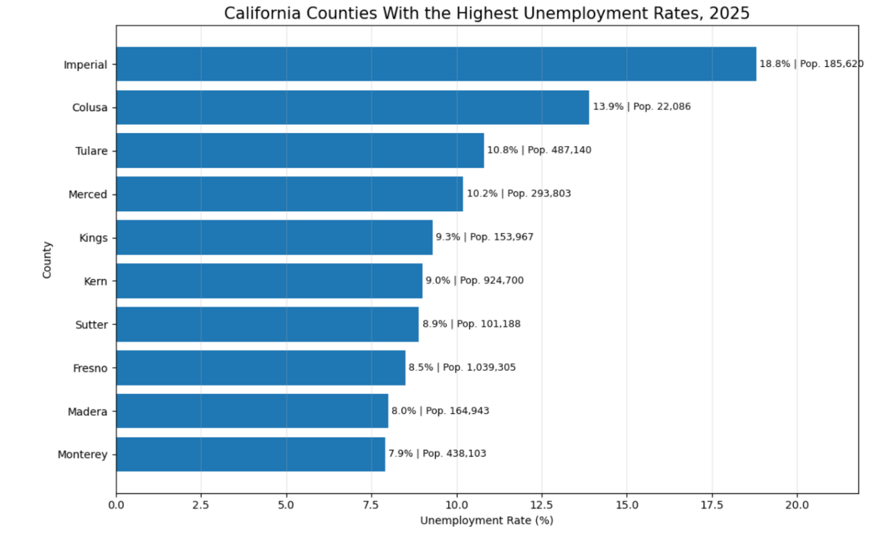
Figure 2. California counties with the highest unemployment rates, 2025, with population context. Created from integrated CDPH and California EDD data.
Together, the visualizations show that California’s overall labor market can improve while individual counties continue to face very different conditions. The integrated data therefore supports a more targeted approach to workforce decisions. State leaders can use the historical trend to recognize broad changes and identify when additional attention may be needed, while local leaders can use county comparisons to understand how their communities compare with other areas.
Effectiveness of the Visualizations
The line chart is effective for the state-level audience because it presents time sequentially and makes changes in direction immediately visible. The peaks around 2010 and 2020 stand out clearly, as does the long decline during much of the 2010s. A table containing the same annual values would require the audience to compare numbers individually, while the line chart communicates the overall pattern quickly. The chart therefore supports the high-level perspective state decision-makers need.
The horizontal bar chart is effective for county and local stakeholders because bar length makes county unemployment rates easy to compare. Ordering the counties by unemployment rate directs attention to the communities facing the highest rates, and the horizontal layout keeps county names readable. Adding population beside each unemployment percentage integrates information from both datasets without requiring a separate chart. This helps the audience consider both the severity of the unemployment rate and the size of the community.
The two visualizations also work together as a multi-level narrative. The first answers how California’s unemployment conditions have changed over time, while the second answers where the highest current unemployment rates are concentrated. Moving from a statewide trend to county-level detail creates a logical progression and prevents the visualizations from functioning as unrelated charts.
Visualization Customization for the Two Audiences
For California state workforce and economic-development leaders, the statewide line chart receives the greatest emphasis. A descriptive title, clearly labeled axes, chronological ordering, and a consistent unemployment-rate scale keep attention on the long-term trend. The county visualization then narrows the focus to the ten counties with the highest 2025 unemployment rates rather than displaying all 58 counties. Limiting the number of counties reduces clutter and helps state leaders quickly identify areas that may warrant additional investigation or support.
For county and local workforce-development officials, the detailed county chart receives greater emphasis. Sorting the counties by unemployment rate provides an immediate frame of reference, while displaying the percentage and population beside each bar reduces the need to estimate values or consult another dataset. These customization choices make the information easier to interpret for local decisions involving employment services, job-training programs, employer outreach, or other workforce initiatives.
The customization does not change the underlying evidence; it changes which information is emphasized for each audience. State leaders receive a broad-to-detailed view centered on trends and prioritization, while local officials receive a focused comparison centered on community-level conditions. This improves clarity because each group can quickly locate the information most relevant to its decisions while still seeing how the findings connect to the larger California labor market.
Conclusion
The integrated analysis demonstrates why labor-market decisions benefit from multiple levels of data. California’s statewide unemployment trend shows major periods of disruption and recovery between 2000 and 2025, while the county comparison shows that current conditions vary substantially across the state. Adding population provides further context for understanding the scale of the communities represented by those unemployment rates. Together, the two visualizations give state and local stakeholders different but connected views of the same issue. The result is a clearer data-driven narrative that can help decision-makers identify trends, recognize geographic differences, and determine where additional analysis or workforce support may be most useful.

References
California Department of Public Health. (2026). California population estimates by age/race_ethnicity/sex at local health jurisdiction level [Data set]. State of California Open Data. https://lab.data.ca.gov/dataset/california-population-estimates-by-age-race_ethnicity-sex-at-local-health-jurisdiction-level
California Employment Development Department. (n.d.). Labor market data search tools: Labor force and unemployment. Labor Market Information Division. https://labormarketinfo.edd.ca.gov/data/labor-market-data-search-tools.html

